
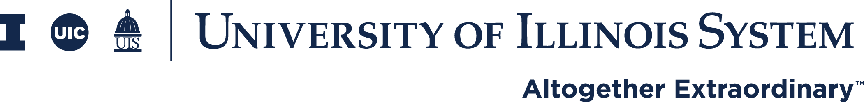
Data Analytics Architecture Roadmap

October 2022

Table of Contents
1. Executive Summary 4
Context 4
Work Performed 4
Recommendations 4
Estimated Investment and Benefit 4
2. Project Description 5
User Perspective 5
Technologies 6
Data Virtualization 6
Data Storage 7
Data Movement 8
Data Visualization and Reporting 8
Data Science 9
Gap Analysis 9
Project Approach 11
Selecting Vendors for Analysis 12
Vendors who chose not to participate 12
Requirements 12
3. Analysis and Results 13
Data Virtualization 13
Vendor Selection for Data Virtualization Proof of Concept 13
Data Virtualization Proof of Concept Demonstrations 14
Data Virtualization Proof of Concept Hands-on Testing 15
Data Virtualization Performance Test Results 15
Data Virtualization Proof of Concept Results 15
Final Decision Regarding Data Virtualization 17
Data Storage 18
Vendor Selection for Data Storage Proof of Concept 18
Data Storage Proof of Concept Demonstrations 19
Data Storage Proof of Concept Hands-on Testing 19
Data Storage Performance Test Results 19
Data Storage Proof of Concept Results 20
Final Decision Regarding Data Storage Architecture 21
Data Movement 22
Vendor Selection for Data Movement Proof of Concept 22
Data Movement Proof-of-Concept Demonstrations 23
Data Movement Proof-of-Concept Hands-on Testing 23
Data Movement Proof of Concept Results 23
Final Decision Regarding Data Movement Architecture 24
Data Visualization and Reporting 25
Vendor Selection for Data Visualization and Reporting Proof of Concept 25
Data Visualization and Reporting Proof of Concept Demonstrations 26
Data Visualization and Reporting Proof of Concept Vendor Demonstrations 26
Data Visualization and Reporting Proof of Concept Accessibility Demonstrations 26
Data Visualization and Reporting Proof of Concept Results 26
Final Decision Regarding Data Visualization and Reporting 28
Data Science 29
Vendor Selection for the Data Science Proof of Concept 29
Data Science Proof of Concept Demonstrations 30
Data Science Proof of Concept Hands-on Testing 30
Final Decision Regarding Data Science 31
4. Next Generation Data Analytics Roadmap 32
Data Virtualization 33
Data Storage 33
Data Lake 34
Data Warehouse 34
Data Movement 34
Data Visualization and Reporting 35
Reporting 35
Data Visualization 35
Data Science 35
Roadmap implementation matrix 36
Implementation Planning 37
Phase 1 37
Phase 2 37
Roadmap Timeline 37
Projected Phase 1 Timeline 37
Project Phase 2 Timeline 37
Appendix 1 – Project Stakeholders and Advisory Group 38
Project Advisory Group 38
Project Stakeholder Group 38
Chicago 38
Springfield 38
System Office 39
Urbana 39
Appendix 2 – Requirements 40
Appendix 3 – Proof of Concept Use Cases & Scorecards 41
Data Virtualization 41
Data Storage 41
Data Movement 41
Data Visualization and Reporting 41
Data Science 41
Appendix 4 – Vendor Justifications 42
Justifications for Data Virtualization Vendors 42
Justifications for Data Storage Vendors 42
Justifications for Data Movement Vendors 43
Justifications for Reporting Vendors 43
Justifications for Data Science Vendors 43
Appendix 5 – Accessibility Requirements 45

1. Executive Summary

Context
Based on feedback from employees who perform data analytics work across the system, the Information Technologies Prioritization Committee (ITPC) approved an analysis project tasked with establishing a set of recommended changes to the current data analytics architecture. Multiple areas for improvement were identified, which include better integration and sharing of enterprise and unit data; more optimized data processing; intuitive data visualization and delivery; and advanced analytical capabilities. Further, concerns with respect to accessibility compliance and data security were raised as overarching concerns across the current data analytics architecture. With the goal of addressing these concerns and enabling the University of Illinois System to become more data driven, AITS partnered with Huron to identify the components of a next generation of data analytics tools along with a roadmap for transitioning from the current to the future state.

Work Performed
Beginning with the advisory group and other key stakeholders, AITS performed a gap analysis to identify as many opportunities as possible in the current data analytics architecture and mapped them to the five broad domains that the supporting technologies fall into. These five are: Data Virtualization, Data Storage, Data Movement, Data Visualization and Reporting, and Data Science. Concurrently, a series of live sessions were held with stakeholders across the System to understand their needs better as well as the benefits they are expecting to realize when a next generation of analytics is implemented. From there, potential vendors and tools were identified for each of these domains. Vendors were invited to give product demonstrations and show that their product met specific proof of concept requirements. Tools were also tested from both technical and functional standpoints, which included accessibility standards. Cost information for the short list of tools in each domain was gathered. Tools were identified for recommendation based on an analysis of features, performance, and cost. The data for each recommended tool was then entered into a model to provide a rough order of magnitude estimate of costs over a five-year period.

Recommendations
To address the needs of the user community, the following products have been selected as the recommended solutions for each technology:
Data Virtualization: Denodo
Data Storage (Data Lakes): Microsoft Azure
Data Storage (Data Warehouse): Azure or Snowflake
Data Movement: Informatica Power Center and Talend
Data Visualization: Tableau and/or Power BI
Reporting: SAP Business Objects 4.3.X+
Data Science: IBM Cloud Pak for Data
All recommendations are subject to accessibility testing, funding, and procurement work.

Estimated Investment and Benefit
Based on the recommendations above and subject to variations in selection, timing and staffing models, a rough order of magnitude estimate for the investment required ranges between $7.7 and 11.2M over a five-year period. As a result of increases to the availability and timeliness of data for enhanced decision making, a rough estimate of the benefits is anticipated to be between $18.6 and $21.0M over the same period with an approximate return on investment (ROI) of 65%.

2. Project Description
ITPC-0621 Data Analytics Architecture Modernization Analysis project was established to create the roadmap to define the next generation of data analytics tools to be made available for use at the University of Illinois System.
Next generation data analytics technologies allow for better sharing and collaboration of data. Enhanced visualization capabilities deliver actionable insights and create more informed decision making.

User Perspective
The following user story offers a high-level understanding of what can be achieved with a modernized data analytics environment. Some of the terminology may be unfamiliar but it will be explained in more detail in the section that immediately follows. The purpose of this story is to highlight the roles that data architecture components play behind the scenes and the benefits each contributes to the journey that begins with prospective student through being an alum who gives back to the institution.
Students go through various phases beginning before they are admitted. A student’s journey starts as a prospect or an applicant. Hopefully, they graduate and become alumni, but we know that many stop out somewhere along the way for various reasons. If they stop out, we want to bring them back so they can finish their degrees and become alumni. As alumni who have gone on to build successful careers, many become donors or maintain ties to the institution by giving back in other ways.
Prospective students are typically tracked in one of the customer relationship management (CRM) applications. These applications are specialized for populating and tracking prospects through the enrollment funnel and, to measure engagement once students are enrolled. Once these individuals are either accepted or admitted students, data with respect to their activities such as registrations, grades, financial aid, on-campus housing, etc. is entered into the primary student information system (SIS). After graduation, data in the SIS stops being updated and the alumni office starts to track them in a CRM that is specialized for fundraising. By this point, the same person has had data collected about them in multiple, disconnected systems. Data in each of these systems is narrowly focused on the day-to-day operational goals those systems support.
To expand the timeframe and glean insights about, for example, how many prospective students went on to graduate with a specific major, the data from the enrollment CRM needs to be combined with either the SIS or the fundraising CRM if it includes information about the majors of the alumni. The benefit to knowing how many prospects are likely to declare a specific major informs the planning process because the pool of prospects is known before admission decisions are made.
This project directly enables these kinds of actionable insights for strategic decision-making. Of the technologies involved in this modernization effort, the least visible but most foundational is the Data Storage component. Currently, there is a data warehouse solution that holds data from disparate systems. However, the ability to make data available in the warehouse requires specific access and highly specialized technical skills. By adding a data lake solution, the barrier to storing data in a central repository is significantly lowered. In our story about the student lifecycle, a department wants to track a specific cohort with characteristics that are likely to change over time. A one-off dataset that identifies the members of this cohort can be added to the data lake for tracking purposes.
Once the data is stored in either the data warehouse or data lake it is rarely in the final form that is useful for reporting purposes. Sometimes additional elements need to be derived from other existing data. Perhaps current age needs to be derived from a person's date of birth. Currently, that data element can be derived at the time that the data warehouse is being populated and refreshed through a Data Movement process called Extract Transform and Load (ETL). Again, adding data elements to the ETL process has a high barrier for users to cross as it requires access and skills that are limited to the AITS team. By adding data virtualization to the analytics architecture, the barrier to defining data elements and data sets for reporting purposes is reduced, allowing units more flexibility. With the combination of data lakes and data virtualization, one area can define a cohort and share that data so that another area can combine it with operational data from the data warehouse. Here is where the potential exists, for example, for the advancement office, to find out how many of their current donors were part of a specific marketing campaign.
To this point, much of the technology discussed is focused on the people who need to interact with the data. Data Visualization and Data Reporting are critical because they turn the data that is available into actionable insights that inform decision making. Upgrading the functionality of reporting and visualization tools enables getting the right information in the right format to the right people at the right time.
Finally, the technologies that have been described so far facilitate getting answers when the questions are known. Data Science is powerful because it can identify patterns in data that would otherwise go unexamined because they are not anticipated. Data science allows us to move from descriptive and diagnostic reporting to predictive and prescriptive analytics. Using our example of the student lifecycle. Once we have collected data about the students who entered the university through many marketing campaigns, what insights are available about the amount of debt these students incurred? Those insights may inform opportunities to provide additional support to those students and reduce their debt load. Similarly, are there any characteristics of the various marketing efforts and the majors that are declared by the students they attract? If so, then there are insights available to help attract students to bolster the departments that offer those majors.

Technologies
With that story in mind, we now turn our attention to describing more fully the technologies included in a next generation architecture.
Data Virtualization – creates a single representation of data from multiple, disparate sources without having to copy or move the data. Virtualization allows users to consume data without needing to be aware of its type or storage location.
Gartner defines data virtualization as “technology is based on the execution of distributed data management processing, primarily for queries, against multiple heterogeneous data sources, and federation of query results into virtual views. This is followed by the consumption of these virtual views by applications, query/reporting tools, message-oriented middleware, or other data management infrastructure components. Data virtualization can be used to create virtualized and integrated views of data in-memory, rather than executing data movement and physically storing integrated views in a target data structure. It provides a layer of abstraction above the physical implementation of data, to simplify querying logic.”
Source: https://www.gartner.com/reviews/market/data-virtualization

A data analyst can use data virtualization to create logical data sets. Logical data sets can be used to join data from multiple sources including the Enterprise Data Warehouse (EDW). For example, if the analyst has access to the EDW, an API containing data, and a file with data, they can create a single dataset for themselves that combines that data into one virtual source. Each source may contain the UIN or CFOAP and the data can be integrated together. Each dataset would still reside in its original location allowing data retention and security to managed at each location. Data analysts will have a complete picture of all their data without completing complicated and costly data movement and transformation processes.
Data virtualization tools also allow the creation and delivery of APIs that can be used to expose data enterprise or local data sources.
Data Storage (Data Lakes and Data Warehouses) – data storage tools are used to physically store data. Data is moved to a data lake or data warehouse from one or more source applications or data systems.

A data lake is a storage technology that stores data in raw or curated formats to be used on its own or in collaboration with other data sets. Typically, data in a data lake is curated when it is retrieved from the data lake.
Gartner defines a data lake as “a concept consisting of a collection of storage instances of various data assets. These assets are stored in a near-exact, or even exact, copy of the source format and are in addition to the originating data stores.
Source: https://www.gartner.com/en/information-technology/glossary/data-lake

Data users want a place where they can physically store their unit specific data. The data lake provides a supported location for units to store university data and use it when needed. Data stored in a lake can be shared with others who are authorized and have been granted access.

Data analysts can access this data and use it for analysis or reporting. It can also be joined with other data in the data lake or in a data warehouse. For example, a unit could develop a standardized curated dataset and store it within the data lake for their own use. They can then share that data with other authorized users at the university if necessary. Additionally, data from other units in the data lake can be easily integrated with the unit’s data because of the common platform. The advantage to the university is that authorized users can store and share data in a common, university managed platform, which does not require the unit to setup its own storage location.

There are many reasons why a university shares data with third party entities. Examples of this could be for financial analysis, university rankings by certain publishers, or data used for professional certification programs. A data lake can be used to facilitate the sharing of data for these purposes as well.

Data Virtualization also allows units to integrate existing data and share with authorized users. But it does not provide a place to store that data. Existing systems must be used, or new platforms need to be setup. Data Virtualization and Data Lakes complement each other because of the benefits that both provide enhance data integration and storage for the university.
A data warehouse is created to store data in a curated format that is used to meet specific data analysis and reporting needs. The primary focus for the data warehouse is to provide access to data and to make reporting on that data easier. A common difference between data warehouses and data lakes is that extensive data processing and preparation is completed to meet client requirements before data is loaded into the data warehouse.
Modern analytics architecture utilizes cloud services for data warehouses. Cloud based data warehouses allow resources to be added or removed on the fly to maintain peak performance levels. Simplified data management processes are also an advantage of cloud-based data warehouses.
Proactively moving the data warehouse for the University of Illinois to the cloud, positions us with an eye toward the future. Increasingly, data sources are moving the cloud. This includes ERP solutions. Having a cloud-based data warehouse in place will simplify the transition as the university implements new cloud-based applications.
Gartner defines a data warehouse as “a storage architecture designed to hold data extracted from transaction systems, operational data stores and external sources. The warehouse then combines that data in an aggregate, summary form suitable for enterprise-wide data analysis and reporting for predefined business needs.

The five components of a data warehouse are:
- Production data sources
- Data extraction and conversion
- Data warehouse database management system
- Data warehouse administration
- Business intelligence (BI) tools

A data warehouse contains data arranged into abstracted subject areas with time-variant versions of the same records, with an appropriate level of data grain or detail to make it useful across two or more diverse types of analyses most often deployed with tendencies to third normal form. A data mart contains similarly time-variant and subject-oriented data, but with relationships implying dimensional use of data wherein facts are distinctly separate from dimension data, thus making them more appropriate for single categories of analysis.”

Source: https://www.gartner.com/en/information-technology/glossary/data-warehouse

Data Movement – data movement tools, also known as ETL (Extract, Transform, and Load) or data integration tools, are used to physically acquire data from one or more data systems (extract), derive new data elements based on existing data (transform) and move it to another central location (load). Specifically, these tools are used at the University of Illinois System to extract data from multiple sources, transform that data by applying business logic, and load the data into one integrated Enterprise Data Warehouse (EDW).
Gartner defines data integration as “the practices, architectural techniques and tools for achieving the consistent access and delivery of data across the spectrum of data subject areas and data structure types in the enterprise to meet the data consumption requirements of all applications and business processes.”

Source: https://www.gartner.com/en/information-technology/glossary/data-integration-tools

Data analysts can use a data movement tool to efficiently move substantial amounts of data into or out of a database.

Modernized data movement tools can connect to data on premise or in the cloud. As the university continues to adopt more solutions in the cloud a data movement tool that can connect to cloud sources is critical.

Data movements tools may also allow the creation and delivery of APIs that can be used to expose data enterprise or local data sources.
Data Visualization and Reporting – Data Visualization and Reporting tools allow end users to consume the data from the EDW and many other data sources. Typical solutions in this area include dashboards, ad hoc reporting, and standard reports. Data visualization is a graphical representation of data. By using elements like charts, graphs, and maps, visualization tools provide a way to see and understand trends, outliers, and patterns in data.
Gartner includes data visualization and reporting under information delivery, which is describes in the following ways:

“Reporting — Reporting provides the ability to create formatted and interactive reports, with highly scalable distribution and scheduling capabilities. In addition, BI platform vendors should handle a wide array of reporting styles (for example, financial, operational and performance dashboards).

Dashboards — This subset of reporting includes the ability to publish formal, Web-based reports, with intuitive displays of information, including dials, gauges, and traffic lights. These displays indicate the state of the performance metric compared with a goal or target value. Increasingly, dashboards are used to disseminate real-time data from operational applications.”

Source: https://www.gartner.com/en/information-technology/glossary/information-delivery

Data Science – data science tools provide a platform for data scientists and others to perform advanced analytical techniques on the data. Users interested in data mining, predictive analytics, text analytics or machine learning would use data science tools.
Gartner includes data science under the general category of advanced analytics, which it defines as “the autonomous or semi-autonomous examination of data or content using sophisticated techniques and tools, typically beyond those of traditional business intelligence (BI), to discover deeper insights, make predictions, or generate recommendations. Advanced analytic techniques include those such as data/text mining, machine learning, pattern matching, forecasting, visualization, semantic analysis, sentiment analysis, network and cluster analysis, multivariate statistics, graph analysis, simulation, complex event processing, neural networks.”

Source: https://www.gartner.com/en/information-technology/glossary/advanced-analytics

Data science techniques such as machine learning and predictive analytics provide universities with a strategic advantage. It allows informed decision making throughout the student lifecycle. Machine learning can guide decisions on which recruits have a higher probability of success. Predictive analytics can be used to identify struggling students so that corrective actions can be taken to maintain high student retention rates and increase degrees awarded.

Gap Analysis
Analytics needs at the University of Illinois have evolved. The current data analytics architecture does not meet all the needs of the data analytics community. Leading up to this effort several gaps were identified. These include:
While there is currently a data movement tool in use, its use is limited to AITS staff. In cases where it would be appropriate for other areas to participate in data movement specific to their area, that capability does not currently exist.
While advanced analytics tools have been adopted on an ad-hoc basis by some units, other units are without these technologies. Adopting one enterprise-wide advanced analytics tool would address that gap.
Options for data storage for local and/or unit data are limited. Units are forced to find data storage solutions. Modern data storage solutions address this gap.
Data virtualization capabilities which would allow users to access the data they need without requiring additional data storage capacity, flattening the data storage cost curve.
Current data integration tools are limited to the types of data sources that can be accessed. There are also limitations to the data types that can be recognized. Modern data integration tools have support for modern data sources, allowing the university to source data from many new systems.
Accessing data from the enterprise data systems is done through utilizing a query language. Units who develop their own applications want to be able to access data through an Application Programming Interface (API). Many modern data sources offer API access to data. Modern tools provide additional methods for accessing data both in and out of the enterprise data storage locations using APIs.
Integration of local or unit data with enterprise data is difficult. Closing this gap will allow users more opportunities to create data solutions that address all their data needs.
Providing single sign-on for all tools in the data analytics architecture will provide better integration and allow users to access the data they need.
Creating data visualizations and reports requires extensive knowledge of the data. This experience can be improved upon with new tools. Combined with enhanced metadata and data lineage, the development process can be made easier for the developer.
Data literacy will provide understanding of common data management and business intelligence concepts, and addresses gaps in understanding of specific university data. Improved data literacy will also make working with data easier.
Creating new data sets, data visualizations and reports is a time-consuming process. Modern tools provide better data access, better data preparation techniques, and more intuitive interfaces and workflow which all lead to shortening the time spent in the development cycle.
Addressing all the identified gaps leads to reducing costs in developing and sharing data and reporting solutions. Better accessibility reduces risk of non-compliance. And we can continue to deliver on our promise to provide data that the university community can trust. The next generation data analytics environment will provide university decision makers with information they need to enable actionable insights.

Project Approach
Execution for the analysis of data analytics technologies and the roadmap development was broken down into three phases: preparation, analysis, and results.

The overall approach to the project so far followed three rough phases. During the preparation stage, key stakeholders and vendors were identified and information was gathered from these two groups while project requirements were formulated. Based on these requirements, the analysis stage began with the creation of use cases which were then addressed by the vendors through proof-of-concept demonstrations. Additionally, the tools offered by the vendors were tested both in terms of functionality and accessibility. The last stage incorporates the results of the analyses into a list of recommended vendors and tools along with a roadmap for implementation.
For a list of the Advisory Group and Stakeholder Group memberships see Appendix 1.

Selecting Vendors for Analysis
A market scan was completed to identify vendors who had data analytics tools. The following vendors were invited to participate due to their availability with university contracts.
Data Virtualization | Data Storage | Data Movement | Data Visualization  and Reporting | Data Science
Amazon  Databricks  Denodo  DOMO  Dremio  IBM Cloud Pak  Informatica  Microsoft Polybase  Oracle Cloud Infrastructure  SAP HANA  SAS ACCESS  Talend  TIBCO | Amazon AWS  Cloudera  Education Advisory Board  Ellucian Analytics  IBM Data Stage  Microsoft Azure Synapse  Oracle *  SAS  Snowflake  Terradata | Erwin  Informatica *  Mattilion  SAS  Talend  TIBCO | Birst  Domo  Dremio  Dundas BI  Google Looker  IBM Cognos  Incorta  Infor Birst  Microsoft Power BI  Microstrategy  Oracle OBIEE  Qlickview  Qlik  SAP Analytics Cloud  SAP Business Objects *  SAS Visual Analytics  Silectis | Alteryx  Amazon SageMaker (+)  Cloudera  DataBricks  DOMO  Education Advisory Board  Google BigQuery ML  IBM Cloud Pak  KNIME *  Microsoft Azure ML  Rapid Minder  SAP Analytics Cloud
* Denotes a current vendor of an enterprise data architecture solution

Each vendor was asked to provide a one hour presentation on their tools. Any vendors who did not wish to participate or did not perform well in the presentations were eliminated. Each of these presentations was recorded and saved in the Project Documentation within Microsoft Teams. Anyone who could not attend the demonstrations was encouraged to watch the recordings. These recordings were used when selecting vendors for the proof of concept phase of the project.

Vendors who chose not to participate
- Ellucian
- Terradata

Requirements
Starting the project with presentations from various vendors allowed the core project team and stakeholders to learn the capabilities of modern data analytics solutions. Following the vendor presentations, we began a comprehensive requirement gathering process.

The initial set of requirements was shared with project stakeholders. Stakeholders were asked to provide feedback and expand upon the initial list. Feedback was integrated into a consolidated and comprehensive list of requirements. The final steps included applying a score and ranking the requirements. The following method was used to score each requirement:
- Requirements that were deemed to be mandatory (legal, security, etc.) were given a score of 99
- Two points for each stakeholder who indicated that a requirement was a “must have”
- One point for each stakeholder who indicated that a requirement was a “nice to have”
For the completed set of Requirements see Appendix 2.
The ranked requirements were used as an input into creating a set of use cases for each technology. These use cases would form the basis of the Analysis phase. For the completed set of Use Cases see Appendix 3.

3. Analysis and Results
The next phase of the project was the proof of concepts. This section of the document will be used to describe the proof-of-concept process and results for each of the five technologies. For additional justifications regarding vendors see Appendix 4.

Data Virtualization
An analysis of the consolidated requirements suggested that the greatest benefits from modern technologies could be realized with implementing Data Virtualization. Therefore, this was the first proof of concept to be initiated.

Vendor Selection for Data Virtualization Proof of Concept
The first task was to identify the vendors who provided Data Virtualization capabilities. We reviewed recordings of initial vendor demonstrations. We also utilized our contract with Gartner, a technological research and consulting firm.
Specifically, we used the Gartner interactive product rating tool for Data Integration to gather industry data on Data Virtualization tools. The results are shown below.
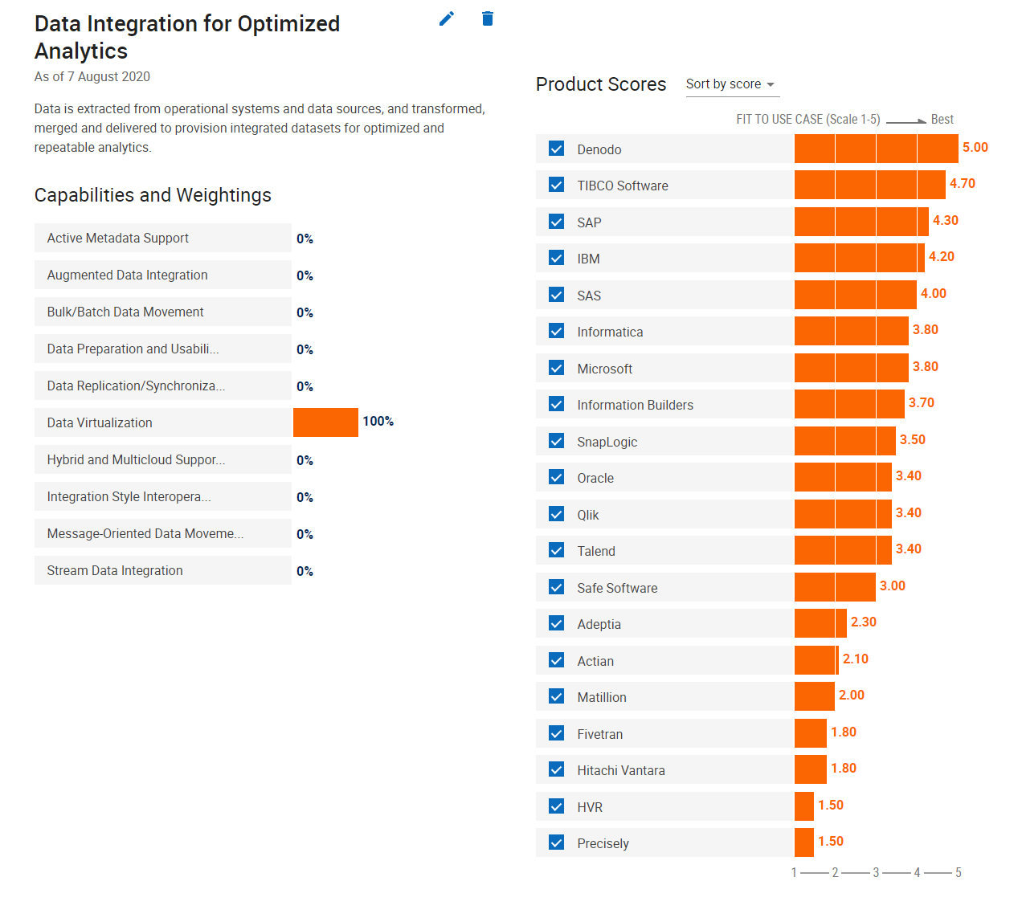
Based on stakeholder feedback, preference of tools from demonstrations, and the Gartner rankings, we chose to do proof of concept demonstrations and testing with the following vendors:
- Denodo
- Microsoft (Polybase is the Microsoft Data Virtualization tool)
- SAP HANA
- SAS

Data Virtualization Proof of Concept Demonstrations
The sequence of events for proof of concept demonstrations by vendors was:
- Develop POC use cases for data virtualization (See Appendix 3)
- Develop data virtualization stakeholder scorecard (See Appendix 3)
- Share the POC use cases for data virtualization and request vendor assistance with preparing the proof of concept demonstration
- Meet with each vendor for 1 hour to:
  - Discuss the POC Demonstration
  - Answer questions they have from the POC use cases
  - Discuss environment setup and preparation for POC testing
- AITS Business Intelligence Architecture (BIA) staff ensured the environments were setup and configured for the presentation. BIA provided the demonstration for each of the vended solutions included in the data virtualization POC. The POC demonstrations were recorded and stored in the Microsoft Teams along with other POC documentation.

Data Virtualization Proof of Concept Hands-on Testing
Following the demonstrations AITS and University Department Resources did testing with the following tools:
- Denodo
- Microsoft Polybase
- SAP HANA
- SAS was included in the POC demonstrations, however, was not tested by the project team due to the delays caused by NDA negotiations
To test Data Virtualization, the project team created three logical data sets utilizing University data. These included Section Capacity, Course Section and Finance. Other testers were encouraged to create their own logical data sets.
University departments who participated in this testing included:
- Technology Services – University of Illinois at Urbana-Champaign
- Office of Institutional Research – University of Illinois at Chicago
- University Office of Planning and Budget – University of Illinois System

Data Virtualization Performance Test Results
Three queries were created and ran against each of the data virtualization tools to capture performance metrics. The general descriptions of what the queries were doing is as follows:
- Query 1 is a simple list of course and section information from the Section Capacity data mart for a specific term. Query 1 returns 53,969 rows.
- Query 2 is a list of course and section information with an aggregated calculation grouped by college for a specific term. Query 2 returns 18 rows.
- Query 3 is a grouped list of finance information with aggregated calculations. The primary table has 730 million rows and the grouped results total 2,425 rows.
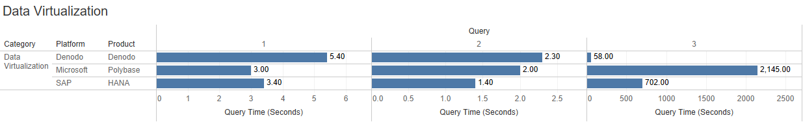
While there was a range in performance test results, all tools fell within acceptable ranges. The exception is Query 3 with the Microsoft Polybase tool.

Data Virtualization Proof of Concept Results
Rating for each of the vendors included the following factors:
- Graphical User Interface – Does the user utilize a graphical user interface or are they expected to write code to build, share and interact with the data virtualization tool?
- Ease of use – How intuitive/easy is it to build, share and interact with the data virtualization tool?
- Build and Share Logical Data Sets – How does the tool compare with others for capabilities when building and sharing logical data sets?
- Connect Business Intelligence Tools to Logical Data Sets – Can Business Intelligence tools use the logical data sets created within the tool as their source for data.
- Provide Capabilities to work with Application Programming Interfaces (APIs) – Can the data virtualization tool use an API to source data from application data stores? Can the virtualization tool provide API capabilities to allow applications to use the logical data sets as a source of data?
- Allow Federated Access Management – Can units manage access to their logical data sets?
- Performance test results – How well did the data virtualization tool perform vs. the other tools tested.
- Cost – How does the cost of the data virtualization tool compare with the other tools that were included in this analysis?
 | Denodo | Microsoft Polybase | SAP HANA
Graphical User Interface |  |  | 
Ease of Use
Build and share logical data sets
Connect business intelligence tools to logical data sets
Provide capabilities to work with APIs
Allow federated access management
Performance test results
Relative Cost | $$ | $ | $$

Legend
 | Exceeds minimum requirements in ways that offer an advantage
 | Meets minimum requirements
 | Fails to meet minimum requirements
NA | Not tested or not applicable

Final Decision Regarding Data Virtualization
Based on all the factors described above and the results from the performance testing Denodo is our current choice for the Data Virtualization tool, subject to accessibility testing.

Data Storage
Stakeholder requirements indicate that storage capabilities for local data or non-enterprise data, are limited for units within the University of Illinois System. Data Analysts also want to join that local data with enterprise data from the EDW and other sources. They also want to share that data and collaborate with others. Modern data storage technologies such as Data Lakes and Date Warehouses can address these needs. AITS currently provides an Oracle Data Warehouse, however an enterprise solution for Data Lakes is not currently offered.

Vendor Selection for Data Storage Proof of Concept
The first step was to review the Gartner Magic Quadrant for Data Management systems:
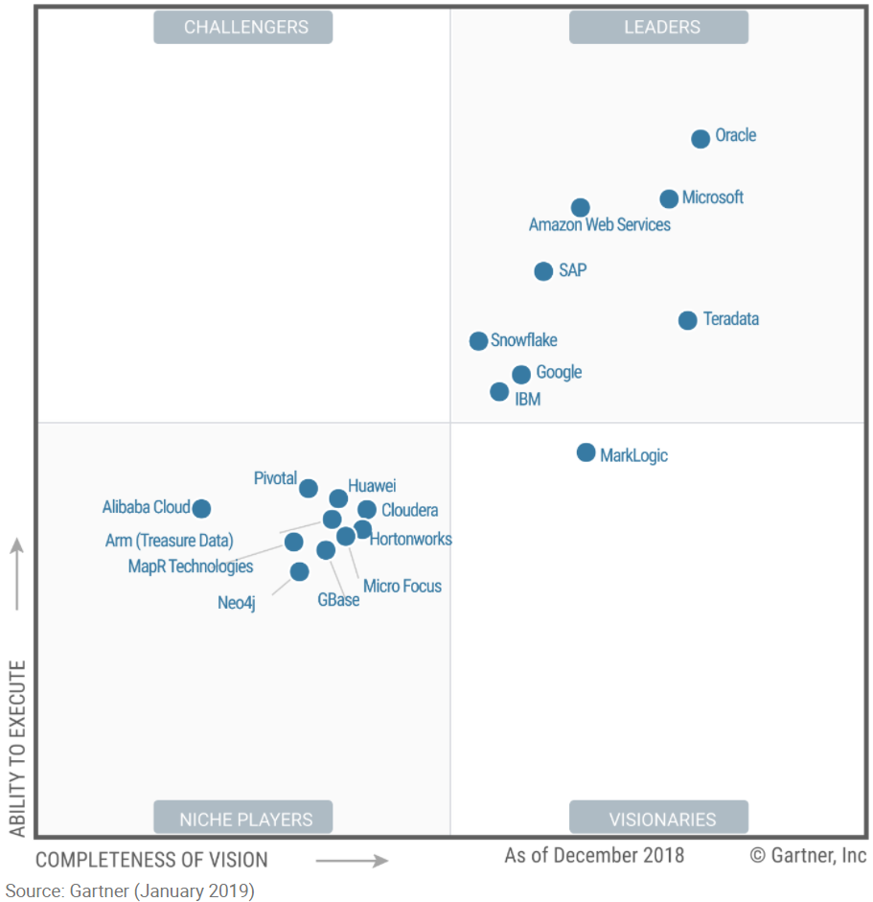
We compared the leaders in the Gartner Magic Quadrant with the vendors we reviewed during the initial vendor presentations. To select the vendors for the Data Storage POC we focused on the vendors in the Leaders quadrant, and we reviewed stakeholder feedback. By doing that analysis we chose to do proof of concept demonstrations and testing with the following vendors:
- Amazon Web Services
- Google Cloud
- Microsoft Azure
- SAP HANA
- Snowflake

Data Storage Proof of Concept Demonstrations
The sequence of events for proof of concept demonstrations by vendors was:
- Develop POC use cases for data storage technologies (See Appendix 3)
- Develop the data storage stakeholder scorecard (See Appendix 3)
- Share the POC use cases for data storage and request vendor assistance with preparing the proof of concept demonstration
- Meet with Each vendor for 1 hour to:
  - Discuss the POC Demonstration
  - Answer questions they have from the POC use cases
  - Discuss environment setup and preparation for POC testing
- Vendor demonstration

Data Storage Proof of Concept Hands-on Testing
Following the demonstrations AITS and resources from the Huron Consulting Group performed hands on testing with the following environments:
- Amazon AWS
- Microsoft Azure
- Snowflake
To test data lakes and data warehouses, the project team created three data sets in each of the tools. These included Section Capacity, Course Section and Finance.

Data Storage Performance Test Results
Three queries were created and ran against each of the data lake and data warehouse tools to capture performance metrics. The general descriptions of what the queries were doing is as follows:
- Query 1 is a simple list of course and section information from the Section Capacity data mart for a specific term. Query 1 returns 53,969 rows.
- Query 2 is a list of course and section information with an aggregated calculation grouped by college for a specific term. Query 2 returns 18 rows.
- Query 3 is a grouped list of finance information with aggregated calculations. The primary table has 730 million rows and the grouped results total 2,425 rows.
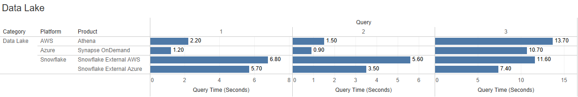
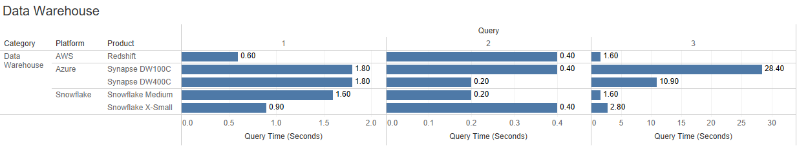
Data Lake performance results show that Azure Synapse performed best overall. The exception being when testing Snowflake using Azure for external storage. The largest of the queries completed in the shortest amount of time in that scenario. For queries 1 and 2 Snowflake took the longest to complete.
For Data Warehouses, differences in query performance on the first two queries were negligible. For Query 3 the Microsoft Azure performance results were poor when executed against the smallest sized data warehouse. When executed on a larger sized environment query performance improved, however it still lagged Amazon Redshift and Snowflake.

Data Storage Proof of Concept Results
Ratings for each of the vendors included the following factors:
- Ease of Use – How intuitive/easy is it to build, share and interact with the data storage tool?
- Loading, Processing and Accessing Data – How intuitive/easy is it to create data sets, load data and share data with others?
- Inventory of Data – Can the data storage tool create usable inventories of data stored in a data lake and data warehouse?
- Governed Access/Authentication – Can the data storage tool use university access and authentication controls to manage access to the data storage tool and the data stored within?
- Separating Workloads – Does the data storage tool process requests in an efficient manner by separating workload?
- Performance Test Results – How well did the data storage tool perform vs. the other tools tested?
- Cost – How does the cost of the data storage tool compare with other tools that were included in this analysis?
 | Microsoft Azure | Snowflake | Amazon AWS
Ease of use
Loading, processing, and accessing data
Inventory of data
Governed access/authentication
Separating workloads
Performance test results
Relative Cost | $$ | $$ | $$

Legend
 | Exceeds minimum requirements in ways that offer an advantage
 | Meets minimum requirements
 | Fails to meet minimum requirements
NA | Not tested or not applicable

Final Decision Regarding Data Storage Architecture
Based on all the factors described above and the results from the performance testing Microsoft Azure is the choice for the enterprise supported data lake solution, subject to accessibility testing.
The recommendation is to continue to use Oracle as the Data Warehouse technology. Additional research and testing will be done over the next 2 years to identify a path for moving the data warehouse to a cloud storage technology. This allows time for additional collaboration across the University of Illinois System for potential consistent contracts for cloud services. Also, this allows for continued discussions for establishing identity and access management policies for multiple cloud tenants, or to move to a single cloud tenant. Finally, implementation of data virtualization and a data lake service provide the foundation for building a consistent and complete physical and logical architecture for university data. A cloud serviced data warehouse will be the final piece for that architecture.

Data Movement
This section will be reviewed and completed upon completion of testing and analysis for Informatica and Talend
AITS uses Informatica Power Center as our Data Movement Tool. Tool is only used internally; a data movement solution or services are not available to campus units. Some units have expressed a need for a data movement tool. This was identified as a gap.
Other gaps related to data movement that were identified include:
- Limited connection types in the existing data movement tool
- Lack of ability to connect to cloud solutions
- Need to utilize APIs from which to source data.
The gaps will potentially be addressed within the roadmap.
The first task was to identify the vendors who provided data movement capabilities. We utilized recordings of initial vendor demonstrations as well as external resources such as utilizing our contract with Gartner.

Vendor Selection for Data Movement Proof of Concept
The First step was to review the Gartner Magic Quadrant for Data Integration systems:
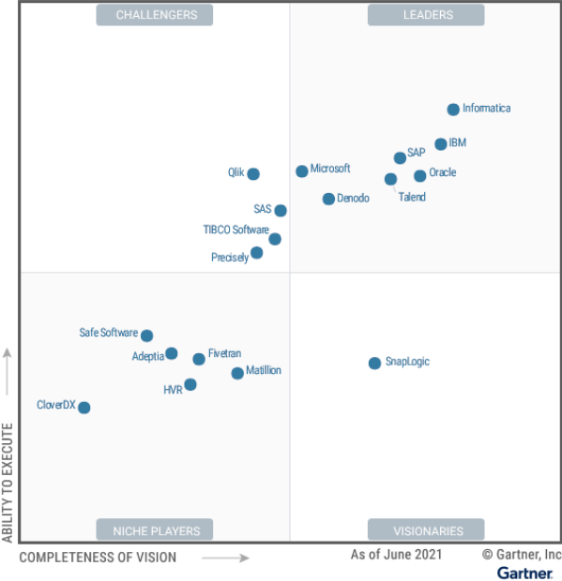
After a review of the Gartner magic quadrant and the recordings from the initial vendor presentations it was determined that we would include the following vendors in our proof-of-concept.
- IBM
- Informatica
- Microsoft
- SAS
- Talend

Data Movement Proof-of-Concept Demonstrations
The sequence of events for proof-of-concept testing was:
- Develop POC use cases for data movement technologies (See Appendix 3)
- Develop the data movement stakeholder scorecard (See Appendix 3)
- Share the POC use cases for data movement with the selected vendors and request vendor assistance with preparing the proof-of-concept demonstration
- Meet with Each vendor for 1 hour to:
  - Discuss the POC Demonstration
  - Answer questions they have from the POC Use Cases
  - Begin discussions about preparation and scheduling the vendor demonstration
- Vendor demonstration

Data Movement Proof-of-Concept Hands-on Testing
Following the demonstrations AITS and resources from the Huron Consulting Group performed hands on testing with the following environments:
- Informatica
- Talend

Data Movement Proof of Concept Results
Rating each of the vendors included the following factors:
- Ease of Use – How intuitive/easy is the tool to use for data movement processes?
- Ability to create targets from multiple data sources – The tool can join tables from multiple databases to create a single output.
- Ability to reuse database connections across schemas – The tool can reuse a single connection per database to retrieve tables across multiple schemas.
- Ability to perform simple/complex transformations
- Ability to bypass rows with errors – During the production run the tool has the capability to quickly bypass errors so the entire run can continue.
- Track data lineage – The tool can provide a quick overview of all column dependencies upstream and downstream within an ETL job.
- Support for version control – The tool provides internal version control.
- Ability to retrieve and load data on a schedule – the tool has internal scheduling capabilities.
- Integration with university application manager tool – the tool integrations with the Automation Application Manager tool to retrieve and load data on a schedule.
- Automated monitoring and notification capabilities – Ability to review and receive notifications on the status of a production run.
- Vendor support
- Cost
The following chart describes the rankings.
 | Informatica Cloud | Talend
Ease of use
Ability to create targets from multiple sources
Ability to reuse database connections across schemas
Ability to perform simple/ complex transformations
Ability to bypass rows with errors
Track data lineage
Support for version control
Ability to retrieve and load data on a schedule
Integration with university application manager tool
Automated monitoring & notification capabilities
Vendor Support
Relative Cost | $$$ | $

Legend
 | Exceeds minimum requirements in ways that offer an advantage
 | Meets minimum requirements
 | Fails to meet minimum requirements
NA | Not tested or not applicable

Final Decision Regarding Data Movement Architecture
Based on all the factors described above and the results from the performance testing Talend is the chosen data movement tool.
The results of the proof of concept review and testing shows that cloud data movement tools are not mature enough to meet all requirements. The recommendation is to continue to use Informatica Power Center on premise and augment that with Talend for data movement for data sources not currently supported by Informatica Power Center. Existing ETL maps will continue to be supported by Informatica Power Center until a later time. New data acquisition will be done using Talend, unless otherwise determined due to Talend’s limitations for bypassing errors.

Data Visualization and Reporting
A key requirement for this project is to identify intuitive and easy to use data visualization and reporting tools. These tools are primarily used for:
- Data Visualization
- Self-service report creation
- Data and report consumption
Currently, AITS provides the SAP Business Objects and Tableau Server as enterprise solutions for the University of Illinois System.

Vendor Selection for Data Visualization and Reporting Proof of Concept
We reviewed all the vendors in the initial demonstration phase who provide tools with Data Visualization and Report Development capabilities. Again, we used the Gartner Magic Quadrant to assist in determining vendors to include in the analysis.
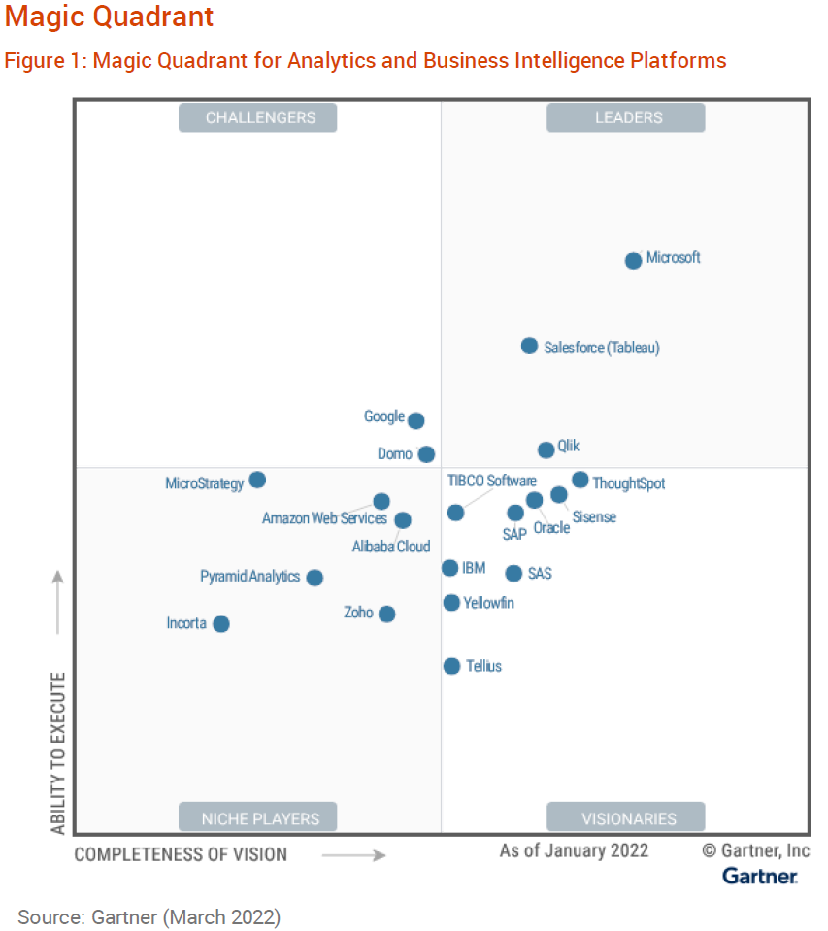
Based on stakeholder feedback, preference of tools from demonstrations, and rankings in the Gartner Magic Quadrant, the following vendors were chosen to participate in the proof of concept demonstrations:
- Google Looker
- IBM Cognos
- Microsoft Power BI
- Qlik
- SAP Business Objects
- SAP Analytics Cloud
- SAS Visual Analytics
- Tableau

Data Visualization and Reporting Proof of Concept Demonstrations
The sequence of events for proof of concept demonstrations by vendors was:
- Develop POC use cases for data visualization and reporting (See Appendix 3)
- Develop the data visualization and reporting stakeholder scorecard (See Appendix 3)
- Share the POC use cases for data visualization and reporting and request vendor assistance with preparing the proof-of-concept demonstration
- Meet with each vendor for 1 hour to:
  - Discuss the POC Demonstration
  - Answer questions they have from the POC use cases
  - Discuss environment setup and preparation for POC testing
- Vendor demonstration
- Vendor Accessibility Demonstration

Data Visualization and Reporting Proof of Concept Vendor Demonstrations
Demonstrations from the selected vendors were provided. After the demonstrations, the project team determined that the following vendor tools did not meet University needs based on the use case demonstrations:
- Google Looker – limited interest was expressed after the use case demonstration.
- SAS Visual Analytics – limited interest was expressed after the use case demonstration.

Data Visualization and Reporting Proof of Concept Accessibility Demonstrations
Much of the data at the University of Illinois is consumed through one or more Data Visualization and Reporting tools. Therefore, it is critical that these tools adhere to accessibility standards. As a result, it was decided that an accessibility review with the vendors would be completed at this stage of the analysis.
The project team collaborated with the Data Visualization Accessibility Committee (DVAC), which was established to support the analysis of tools for this effort. The DVAC provided a set of accessibility requirements to guide the accessibility reviews and testing. These requirements can be found in Appendix 5 of this document.
Vendors were selected for accessibility review based on stakeholder interest and ability to meet our use cases as demonstrated during the POC Use Case demonstration. The vendors who were invited to participate in the accessibility demonstrations included.
- Tableau
- Microsoft Power BI
- Qlik
- IBM Cognos
- SAP Business Objects
- SAP Analytics Cloud

Data Visualization and Reporting Proof of Concept Results
Rating each of the vendors included the following factors:
- Ease of Use - How intuitive/easy is it to build, share and publish business intelligence solutions?
- Data Visualization – Does the tool meet university needs related to creating, publishing, sharing, and consuming data visualizations and dashboards?
- Ad Hoc Reporting – Does the tool meet university needs related to creating and using ad hoc reporting tools?
- Pixel Perfect Reports – Does the tool meet university needs related to creating and consuming pixel perfect reports?
- Allow Federated Authentication management – can business intelligence creators manage access to the solutions which they create and publish?
- Extensive Support for Data Sources – Does the tool have native connectivity to the most common data sources, cloud or on premise?
- Accessibility – Does the tool meet university standards related to accessibility when creating and consuming business intelligence solutions?
- Cost – How does the cost of the data visualization and/or reporting tool compare with other tools that were included in this analysis?
The following chart describes the rankings.
 | Microsoft Power BI | Tableau | SAP Business Objects
Ease of use
Data visualization
Ad hoc reporting
Pixel perfect reports
Allow federated authentication management
Extensive support for data sources
Accessibility
Relative Cost | $ | $$ | $$

Legend
 | Exceeds minimum requirements in ways that offer an advantage
 | Meets minimum requirements
 | Fails to meet minimum requirements
NA | Not tested or not applicable

Final Decision Regarding Data Visualization and Reporting
Analysis of tools shows that no single tool is capable of meeting university needs for data visualization and reporting. Tools that focus on reporting do not have the data visualization capabilities that the current Tableau solution offers. Therefore, the recommendation is to continue to offer a suite of tools to meet all the reporting needs.
It was determined that SAP Business Objects delivers self-service capabilities in both ad-hoc and standard reporting. Therefore, for the roadmap the recommendation is to continue to use SAP Business Objects for this functionality. The recommendation is to upgrade the SAP Business Objects solution to the latest version. Stakeholders favored the modern user interface offered by the latest version of SAP Business Objects. Furthermore, a review of all features of SAP Business Objects will be done to take advantage of new or unused capabilities.
For data visualization the recommendation is to continue using Tableau for the enterprise data visualization solution.
A Microsoft Power BI service is of interest to some stakeholders. However, implementation of this service cannot be delivered at this time due to lack of common identity and access management policies and a lack of a single Microsoft tenant. To support the interest in using Microsoft Power BI, additional research and testing will be done over the next 2 years to identify a path for implementation of a Microsoft Power BI service. This allows time for additional collaboration across the University of Illinois System for potential consistent contracts for cloud services. Also, this allows for continued discussions for establishing identity and access management policies for multiple cloud tenants, or to move to a single cloud tenant. Finally, implementation of data virtualization and a data lake service provide the foundation for building a consistent and complete physical and logical architecture for university data. A cloud serviced data warehouse will be the final piece for that architecture.

Data Science
Across the University System there has been a growing need for advanced analytical capabilities. Data Science is looked at as a strategic competency and is critical to the future success for the University in areas of recruiting, retention, and overall student success.
Currently, the university does not support an enterprise-wide data science tool. Individuals and individual units have their own tools and methods for performing advanced analytics.

Vendor Selection for the Data Science Proof of Concept
The first task was to identify the Data Science tools to evaluate. We reviewed recordings of initial vendor demonstrations. We also utilized our contract with Gartner, a technological research and consulting firm.
Specifically, we referenced the Gartner Magic Quadrant for Data Science and Machine Learning Platforms (see the image below).

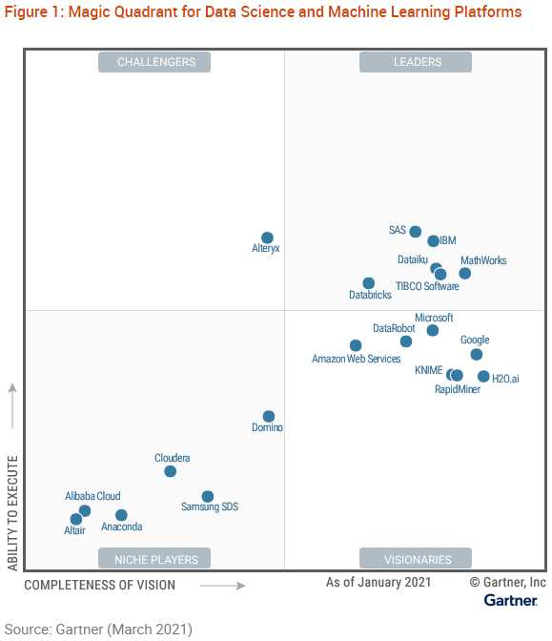
Based on stakeholder feedback, preference of tools from demonstrations and the Gartner rankings, of the vendors who provide demonstrations we chose to do proof of concept demonstrations and testing with the following vendors:
- Alteryx
- IBM
- KNIME
- SAS

Data Science Proof of Concept Demonstrations
The sequence of events for proof of concept testing was:
- Develop POC use cases for data science (See Appendix 3)
- Develop data science stakeholder scorecard (See Appendix 3)
- Share the POC use cases for data science and request vendor assistance with preparing the proof of concept demonstration
- Meet with Each vendor to:
  - Discuss the POC Demonstration
  - Answer questions they have from the POC use cases
  - Discuss environment setup and preparation for POC testing
- AITS Advanced Analytics staff met extensively with each vendor for environment setup and to learn how to use the tools. Each vendor was given ample time for demonstration and knowledge sharing.

NOTE: KNIME was given the same amount of time for their demonstration, however since KNIME is currently used by the testing team training was not a component of the testing phase.

Data Science Proof of Concept Hands-on Testing
A team of testers from AITS Advanced Analytics and Business Intelligence Architecture did extensive testing and documentation of results. The results of this documentation are stored with internal project documentation.
NOTE: KNIME was not tested during this phase. As the current vendor, extensive hands-on testing was not necessary.
Proof of Concept Testing Results
 | IBM Cloud Pak for Data | KNIME | SAS AI | Alteryx
Ease of use
Core data science capabilities (statistics and algorithms)
Text analytics
Integration of data science coding languages
Scheduling and monitoring workflows
AutoML with clustering
Relative Cost | $$$ | $ | $$ | NA

Legend
 | Exceeds minimum requirements in ways that offer an advantage
 | Meets minimum requirements
 | Fails to meet minimum requirements
NA | Not tested or not applicable

Final Decision Regarding Data Science
Based on all the factors described above and the results from the performance testing IBM Cloud Pak for Data is our current choice for the Data Science tool.

4. Next Generation Data Analytics Roadmap
This section describes the Next Generation Data Analytics platform that will be made available for the University of Illinois System. The architecture for the data analytics platform is best described in the Next Generation Data Analytics Platform diagram below.
The three layers of this diagram include:
- Physical Data Layer – Data is ingested from University and Unit data sources into the physical data layer with the use of a Data Movement tool. The Physical Data Layer consists of the data storage utilities – Data Lake and Data Warehouse. Users can acquire data directly from the physical data layer.

- Data Fabric Layer – The data fabric layer allows users to logically join and share data and collaborate with others. The next generation architecture provides more means for accessing data. Data Virtualization allows people to build logical datasets and join data together, regardless of physical location.

The next generation data analytics architecture will also provide better opportunities for data integrations through the creation, delivery, and use of Application Programming Interfaces (APIs). This is becoming increasingly more critical as many of the University’s enterprise applications are moving to cloud-based vendor hosted systems.

Gartner defines data fabric as “a design concept that serves as an integration layer (fabric) of data and connecting processes.” This integration layer allows for more agile data pipelines from multiple, dissimilar sources to provide faster data access and sharing without concern for differences in the systems that typically impede getting those benefits. Additionally, in more mature environments where the metadata is monitored in real time, machine language and other AI techniques can be used to further enhance performance.
Sources: https://www.gartner.com/smarterwithgartner/data-fabric-architecture-is-key-to-modernizing-data-management-and-integration
https://emtemp.gcom.cloud/ngw/globalassets/en/publications/documents/understand_the_role_of_data_fabric_ebook.pdf

- Data Delivery Layer – The data delivery layer provides the utilities which allow users to access and expose data for others. Within this layer consumers can format and share the data using Data Visualization and Reporting tools. Also in this layer are tools which allow users to request data directly from the Logical and Physical data layers (i.e., SQL and/or ODBC connections). The Data Delivery layer includes the Data Science tools used for advanced analytics.
The following constructs are critical to the success of a data analytics environment:
- Data Governance
- Process
- Culture
- Federated Access
Analysis done to create this roadmap has resulted in increased levels of awareness and opportunities for collaboration in these areas.
Security for the next generation architecture is especially important. We will use existing university identity and access management systems to enable strong security protocols to protect the university’s data assets.

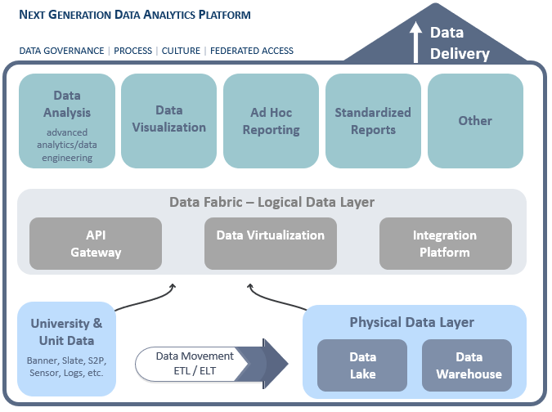

Data Virtualization
Units who have local data and wish to join that with enterprise data or data dispersed in many locations including multiple types (files, APIs, databases, etc.) will benefit immediately from a data virtualization tool. Implementation of Denodo as the data virtualization tool will facilitate the creation of the data fabric. The plan is to implement data virtualization as the first new tool in the modern analytics environment.
Because we do not offer a data virtualization service today there will be no impact to current solutions created and used by the user community. The data virtualization implementation project will include:
- Deploy Denodo for data virtualization capabilities
- Define standards and processes for data virtualization
- Establish the Logical Enterprise Data Warehouse and begin creating logical data sets
- Define API processes and delivery standards for the creation and use of APIs to source and expose data for applications
- Define the service and support models for data virtualization to ensure users of the service can use the tools in an appropriate manner
- Create and administer technical training

Data Storage
Data Storage technologies include data lakes and data warehouses. These will be implemented separately.

Data Lake
The data lake platform will be the first implementation in the data storage area. We will implement Microsoft Azure as the data lake service. This will provide a way for units who have university data not already available in an enterprise system, a location to store their data in an enterprise supported platform and integrate it with other data in the lake. Pairing the data lake service with the Denodo solution for data virtualization will allow users to easily join, share and collaborate with their data and enterprise data.
The data lake service does not exist today. Therefore, deployment of a new service will enhance capabilities while minimizing impacts to the data analytics community. The data lake implementation will include:
- Implementation and configuration of Microsoft Azure Data Lake to be used as a data lake repository
- Identity and Access management (IAM) setup for data lake
- Creation of Job Aids to provide step by step instructions for the most common tasks needed to use a data lake to store and access data
- Training and education on how to share data from a data lake and collaborate with others using that data
- Training and education on how to join data in the data lake with other data sources, including data in the Enterprise Data Warehouse.
- Training on how to use the data in a data lake with enterprise business intelligence solutions

Data Warehouse
We will continue to deliver the Enterprise Data Warehouse using Oracle. Continuing to deliver the data warehouse in Oracle limits the impact to units who currently use the data warehouse in their analytics solutions. Implementation of data virtualization and data lakes before the next generation data warehouse is implemented provides flexibility for transition to a new data warehouse tool. Also, this plan allows time for university policies and procedures to be formed for identify and access management for cloud solutions. This is especially important to an enterprise analytics environment with a goal to provide the same experience for all users, regardless of their university affiliation. The time spent on additional research and analysis provides opportunities to identify additional impacts of changing the data warehouse service.
Implementation plans, deliverables, support, training, and strategies for change management to address impacts of changing data warehouse technologies will be addressed as the future direction is defined.

Data Movement
Additional testing and evaluation will be complete in August and September to determine the roadmap for data movement.
The implementation of the next generation data movement tool will include:
- Deployment of the new data movement application
- Education for ETL Developers
- Define internal standards and processes for creation and implementation of data movement solutions
- Define API processes and delivery standards for the creation and use of APIs to source and expose data for applications
- Conversion of ETL maps from the on premise Informatica tool to the new data movement application
- Creation of services and support models for units to be able to use the data movement application
- Training and education for units

Data Visualization and Reporting

Reporting
SAP Business Objects has been in production since 2002. Implementation of the latest version of SAP Business Objects will provide continuity in the next generation data analytics architecture. The plan calls for an upgrade to the latest version of SAP Business Objects.
A concern raised in the past was that the Business Objects user interface was not user friendly. SAP the vendor has made considerable improvements to the user interface in the latest version of Business Objects. Business Objects also offers many modern capabilities. Some of these capabilities are not currently utilized in the service. Following the upgrade, a review will be conducted of all the capabilities of the new system. Coupled with a modern user interface, these additional capabilities will help close the gaps associated with the existing service. Also, a new standard for the Business Objects semantic layer (Universes) provides flexibility and additional capabilities that allow for the delivery of more intuitive and easier to use solutions.
Units have depended on the Business Objects artifacts they have created for many of their data and reporting needs. Staying on a Business Objects platform allows the university to avoid the costs of time and resources associated with migrating current reporting artifacts to a new solution.
The implementation of the next generation reporting tool will include:
- Upgrade to the latest version of SAP Business Objects
- Updated training and education for using Business Objects
- Updated job aids to account for changes in the latest version of Business Objects
- Review of new and unused features of Business Objects to determine a path for implementation of these features during or after the Business Objects upgrade
- Implementation plans and strategies for migrating the Business Objects Universes to the new standard. Including change management plans to address any impacts realized with migrating to this new standard.

Data Visualization
The current data analytics architecture includes the availability of the Tableau Server. This provides data visualization content creators a place to publish and share their dashboards and data visualizations. Tableau provides the ability for content creators to present their data in an easily consumable manner. Tableau Server will continue to be available in the next generation environment.
There will also be continued research and analysis towards a Microsoft Power BI service. During that time, we will work with university cloud and IAM staff to recommend a cohesive a more cohesive approach. These decisions are critical for implementation of a Microsoft Power BI Service. The time spent on additional research and analysis also provides opportunities to identify impacts of changing the data visualization service. Strategies for change management to address those impacts will be addressed as the future direction is defined.
Implementation plans, deliverables, support, training, and strategies for change management to address impacts of changing data warehouse technologies will be addressed as the future direction is defined.

Data Science
Advanced Analytical solutions are looked at as a strategic advantage for universities today and, interest in advanced analytics at the University of Illinois is growing. It is critical that a service is available for data scientists to deliver solutions that position the university in a way to take advantage of the actionable insights delivered through the data sciences. The research and analysis done during this effort point to IBM as the vendor who can best deliver this service. The IBM Cloud Pak for Data software as a service is chosen as the data science tool for the next generation architecture.
The implementation of a next generation data science tool will include:
- Deploy IBM Cloud Pak for Data
- Define the service and support models for data science ensure users of the service can use the tools in an appropriate manner
- Create and administer technical training and education for using IBM Cloud Pak

Roadmap implementation matrix
The tools will be implemented in phases to move from the current state to the future state.
 | Current | Future | Future - Hosted
Data Virtualization | None | Denodo | On Premise
Data Storage: Data Lake | None | Microsoft Azure | Software as a Service
Data Storage: Data Warehouse | Oracle | Microsoft Azure or Snowflake* | Software as a Service
Data Movement | Informatica Power Center | Informatica and Talend | On Premise and Software as a Service
Data Visualization | Tableau | Tableau and/or Microsoft Power BI* | On Premise
Reporting | SAP Business Objects 4.2.X | SAP Business Objects 4.3.X+ | On Premise
Data Science | KNIME | IBM Cloud Pak for Data | Software as a Service
* Additional research is pending before these decisions can be made.

Implementation Planning
The recommended plan is to implement the technologies included in the Next Generation Data Analytics Architecture in two separate phases.

Phase 1
During phase 1 the focus will be on modern data integration capabilities for connecting, sharing and collaborating with data. Phase 1 technologies include:
- Data Virtualization
- Data Lake
- Data Movement
- Reporting

Phase 2
Phase 2 efforts will focus on migrating to a modern data warehouse solution and advancements in data visualization and advanced analytics tools.
- Data Warehouse
- Data Science
- Data Visualization

Roadmap Timeline
The roadmap timeline lays out the high-level planning and implementation projects for each of the technologies. This includes plans for transitioning artifacts from existing tools to new tools. Note that some transitions may occur after the three-year implementation timeline created for this project.

Projected Phase 1 Timeline
 | FY 2023 |  |  |  | FY 2024 |  |  |  | FY 2025 |  |  |  | FY 2026
 | Q1 | Q2 | Q3 | Q4 | Q1 | Q2 | Q3 | Q4 | Q1 | Q2 | Q3 | Q4 | Q1 | Q2 | Q3 | Q4
Reporting | Upgrade to BO 4.3X |  |  | Conversion of Business Objects to new semantic layer standard
Data Virtualization |  |  |  | Implement Denodo |  | Build Logical Data Warehouse
Data Lakes |  |  |  |  |  |  |  | Implement Data Lake
Data Movement |  |  |  |  |  | Implement New Data Movement |  | Migrate ETL Maps to new tool

Project Phase 2 Timeline
 | FY 2025 |  |  |  | FY 2026 |  |  |  | FY 2027
 | Q1 | Q2 | Q3 | Q4 | Q1 | Q2 | Q3 | Q4 | Q1 | Q2 | Q3 | Q4
Data Science |  |  | Implement Data Science tool
Data Warehouse |  |  |  |  | Implement Data Warehouse |  |  |  | Conversion of Oracle Data Warehouse to new Data Warehouse
Data Visualization |  |  |  |  |  |  |  |  | Implement Data Visualization

Appendix 1 – Project Stakeholders and Advisory Group

Project Advisory Group
Advisory Group Member | Affiliation | Unit
Tanweer Alam | Foundation | Foundation
Sarah Bjelland | Alumni Association | Alumni Association
Laura Dorman | Springfield | Institutional Research
Amy Edwards | Urbana | Institutional Research
Stephanie Estrada | Chicago | Institutional Research
Yanui Guo | Springfield
Vern Huber | Springfield | Information Technology Solutions
Colleen Kehoe | Chicago | Budget and Financial Analysis
Renee Nagy | System Office | University Office of Planning and Budgeting
Radhika Reddy | Chicago | Technology Solutions
Michelle Rome | Urbana | ATLAS
Ryan Thomas | Urbana | Technology Services
Thomas Skottene/Kim Nystrom | Urbana | Enrollment Management
Dimuthu Tilakaratne | System Office | Administrative Information Technology Services
Connie Zdenek | Chicago | Liberal Arts and Science
Sarah Zehr | System Office | Office of the Executive Vice President
Ilir Zenku | Chicago | Health Affairs

Project Stakeholder Group

Chicago
Coogan, Patrick - Office of the Vice Chancellor for Innovation
Dang, Dean - Technology Solutions
Estrada Stephanie - Office of Institutional Research
Fuiten, Matthew - Division of Specialized Care for Children
Ghadeer, Amira - Human Resources at UIC
Hayward, Bill - Office of Institutional Research
Johnson, Akin - College of Medicine, Administration
Kane, Nick – College of Medicine
Kehoe, Colleen - Budget and Financial Analysis
Lafarge, Virginia - Budget and Financial Analysis
Nichols, Andrew - Division of Specialized Care for Children
Maslanka, Jason - Technology Solutions
Moss, Michael - Budget and Financial Analysis
Muench, Jim - College of Engineering
Parekh, Lina - John Marshall Law School
Patangay, Vishakha - Student Affairs Technology
Patel, Bhavin - Office of the Vice Chancellor for Research
Perez, Victor - Human Resources at UIC
Petraitis, Jack - Technology Solutions
Radhika, Reddy – Technology Solutions
Rush, Dale - College of Pharmacy
Sabacan, Maria - Human Resources at UIC
Sayre, Christopher - Registration and Records
Scott, Ken - Human Resources at UIC
Wan, Guofeng (Phoenix) – College of Medicine
Yudt, Angela - Vice Provost of Faculty Affairs
Zdenek, Connie - Liberal Arts and Science
Zhang, Lubing - Budget and Financial Analysis
Zhang, Yufu - Office of the CHIO

Springfield
Bloemer, Bill - Office of the Vice Chancellor for Academic Affairs
Dorman, Laura - Office of the Vice Chancellor for Academic Affairs
Huber, Vern – Information Technology Services
Snider, Ben - UIS Enrollment Management

System Office
Anderson, Mark – University office for Planning and Budgeting
Alam, Tanweer - University of Illinois Foundation
Benson, Shelly - Office of Business and Financial Services
Bjelland, Sarah - University of Illinois Alumni Alliance
Burgener, Todd - System Human Resource Services
Fitch, Tyler - University of Illinois Foundation
Gerini, Susan - Human Resource Services
Jacobs, Angela - University Office of Capital Programs and Real Estate Services
Lehman, Chris - University Office for Planning and Budgeting
Mikel, Sally - University Office for Planning and Budgeting
Nagy, Renee - University Office for Planning and Budgeting
Rasmus, Brent - University Accounting and Financial Reporting
Rogan, Chris - University Office of Capital Programs and Real Estate Services
Zehr, Sarah - Office of the Executive Vice President and Vice President for Academic Affairs

Urbana
Ashmore, Travis - College of Engineering
Britton, Nate - Auxiliary Shared Technology Services
Cha, Ester - Technology Services
Chen, Xiaobei - Office of the Provost
Coleman, Erik - Technology Services
Courtney, Kathryn - Auxiliary Shared Technology Services
Domeyer, Jeff - Technology Services
Edwards, Amy - Division of Management Information
Fradkin, Andres - Facilities and Services
Hege, Eric - Beckman Institute
Hege, Mark - Student Affairs Technology
Hoewing, Rod - Office of the Registrar
Karres, Dean - Beckman Institute
Le, Bic - Beckman Institute
Merrill, Brian - Sponsored Programs Administration
Nystrom, Kim - Enrollment Management Shared Services
Painter, Michael - College of Education
Reiter, Phil - Technology Services
Rome, Michelle - Applied Technologies for Learning in the Arts and Sciences
Skottene, Thomas - Enrollment Management Shared Services
Taylor, Ken - Technology Services
Thomas, Ryan - Technology Services
Tidrick, Chris - Gies College of Business
Trankina, Brad - Facilities and Services
Yu, Jen-Chien - University Library

Appendix 2 – Requirements
Document Tabs:
- General Requirements – requirements that apply to all the different technologies (Data Virtualization, Data Storage, Data Movement, Data Visualization and Reporting, Data Science)
- Implementation – requirements that are specific to implementation of any tools that are selected.
- Data Viz and Delivery – requirements specific to data visualization and delivery tools
- Data Science – requirements specific to advanced analytics/data science tools
- Data Lakes and Data Warehouses – requirements specific to data storage tools
- Data Virtualization – requirements specific to data virtualization tools
- Data Movement – requirements specific to data movement tools
- User Provided Requirements – these are requirements that users identified that were not on the initially generated requirements list. These requirements have been integrated into tabs 1 – 7. A crosswalk of where these requirements are located is provided on the line in this tab.

Appendix 3 – Proof of Concept Use Cases & Scorecards
 | Use Cases | Scorecards

Data Virtualization

Data Storage

Data Movement

Data Visualization and Reporting

Data Science

Appendix 4 – Vendor Justifications
This section provides justifications as to why some vendors were not included or removed from consideration for the roadmap.

Justifications for Data Virtualization Vendors
- TIBCO was ranked second on Gartner’s list. However, TIBCO failed to provide a professional demonstration. A TIBCO demonstration was rescheduled three times and they were unable to meet the commitment.
- The demonstration for IBM’s Cloud Pak solution was not received well by stakeholders. It was deemed as not user friendly.
- Informatica ranked high on the Gartner capabilities. When we requested that Informatica participate in our POC, they stated that they discontinued the data virtualization solution.
- Microsoft was ranked lower by Gartner. They were selected for POC because University interest with Microsoft tools is heightened. Especially with integrations between cloud services within the Microsoft Azure suite of tools.
- Oracle was ranked lower by Gartner but was considered because of its extensive use for databases. However, due to the licensing audits by Oracle, we were advised to not add any new Oracle tools to university licensing.
- We considered AWS Glue even though it was not ranked on the Gartner capability matrix. However, the tool was only for the solutions installed in AWS. It was also very code centric. Therefore, they were removed from consideration. Stakeholders commented that Denodo was easiest to use when connecting to data sets and creating logical/virtual data sets.
- Stakeholders preferred the Denodo interface over the other tools tested.
- Stakeholders commented that the Microsoft Polybase required DBA like skills. This made the system difficult to use for citizen data analysts. This issue was prevalent when creating logical data sets.
- Microsoft Polybase can utilize APIs for sourcing and exposing data sets. However, it requires a third-party driver. Additional costs and resources for maintenance and support would be required.
- Stakeholders commented that SAP HANA was difficult to use due to the necessary levels of customization and programming.
- Stakeholders commented that creating data source definitions in SAP HANA was difficult. However, once the data source definition was available, creating logical tables was intuitive.

Justifications for Data Storage Vendors
- Teradata chose not to participate in our analysis for modernizing our data architecture.
- Oracle was ranked high by Gartner. However, due to the licensing audits by Oracle, we were advised to not add any new Oracle tools to university licensing.
- IBM was ranked as a Visionary in the Gartner magic quadrant. However, they were eliminated from the analysis due to lack of interest identified during additional research and discussions with the stakeholder group.
- SAP HANA – The SAP HANA demonstration was poorly executed, resulting in a lack of stakeholder Support. Thus, SAP HANA was eliminated from consideration.
- Google Cloud – The Google Cloud demonstration was poorly executed, resulting in a lack of stakeholder support. Thus, Google Cloud was eliminated from consideration. University contracts for Cloud services are not consistent between the three universities. Therefore, implementation of any cloud solutions requires additional research and consensus on identity and access management practices.
- Microsoft Azure AD offers the best integration with established university authorization services (i.e., Microsoft Active Directory).
- Initial research on Amazon AWS implementation of Azure AD for authentication and authorization showed challenges that prevent the selection of Amazon AWS the enterprise data storage solution at this time. Additional research and procedures would be required to move forward with Amazon AWS.
- Snowflake is available to be hosted in Amazon AWS, Google Cloud, or Microsoft Azure. Which is beneficial when integrating data from other cloud hosted applications or services.

Justifications for Data Movement Vendors
- Oracle was ranked high by Gartner. However, due to the licensing audits by Oracle, we were advised to not add any new Oracle tools to university licensing.
- Denodo – Denodo was included in the data virtualization proof-of-concept. We deemed this tool to be primarily a data virtualization tool. Therefore, we did not include them in the data movement POC.
- Informatica was selected for the Proof of Concept. Informatica is the current vendor for data movement vendor. AITS has many years of experience working with the on-premise version of Informatica Power Center. After completing the proof of concept, the Cloud version of Informatica was not selected. The interface is not easy to use. Their database connections are based on database and schema which does not allow for reuse and flexibility across schemas. Some existing features, such as Disable a session and Generate SQL override, are not available or supported.
- Talend was selected for the Proof of Concept. This tool does not offer some of the features currently available in our current tool, such as the ability to ignore rows with errors as needed. Separate processing would be required for rows that have errors. Emergency updates would be required if issues occurred during production runs to account for rows that have errors. Talend is the best solution for data acquisition for currently unsupported source data platforms (i.e., cloud data sources such as snowflake, and APIs)

Justifications for Reporting Vendors
- Oracle was ranked as a visionary in the Gartner magic quadrant. However, due to the licensing audits by Oracle, we were advised to not add any new Oracle tools to university licensing.
- Domo and ThoughtSpot were not invited to participate as there was a lack of interest following the initial vendor demonstrations.
- TIBCO failed to provide a professional demonstration. A TIBCO demonstration was rescheduled three times and they were unable to meet the commitment.
- Cognos – was not considered accessible.
- Qlik was not as feature rich as some of the other solutions. Particularly Microsoft Power BI and Tableau. Qlik was not considered accessible.
- SAP Analytics Cloud – was not considered accessible.

Justifications for Data Science Vendors
- Alteryx was ranked as a Challenger by Gartner. There are pockets of use of Alteryx within the system. Therefore, they were included in the analysis.
- KNIME was ranked as a Visionary by Gartner. AITS data scientists use KNIME for workflow creation and execution. Therefore, they were included in the analysis.
- TIBCO was ranked as a leader. However, TIBCO dropped out early in the analysis because they were unable to deliver a demonstration as requested.
- Databricks – Use of Databricks for data science requires using Databricks for the entire architecture stack. They recommended that they not participate in the analysis.
- Alteryx
- No cloud solution is cause for concern with direction of university towards cloud solutions.
- No support for clients using Macs. This can be an issue as Mac is the preferred platform for individuals and units within the University System.
- Alteryx performance lagged that of other vendors that were tested.
- Changes to a model require the entire model to have to be rerun.
- IBM Cloud Pak for Data
- Integration of the IBM Watson tool is seen as a competitive advantage.
- IBM was strongest with text analytics and sentiment analysis. In general, the IBM tool delivered the best solution to meet our requirements and use cases.
- KNIME
- In KNIME, you can execute parts of models that have been changed without being required to execute the entire model. Thus, saving time on execution and testing.
- The consensus is that KNIME does not scale as well for an enterprise solution as the other tools that were tested.
- SAS
- University experience with installation, configuration, and general setup and use for other SAS Viya and other tools is cause for concern. SAS was unable to provide the level of support to effectively help us when needed.

Appendix 5 – Accessibility Requirements
The following document for Accessible ICT Procurement Requirements was prepared by the Data Visualization Accessibility Committee and provided to the project team. It was used to guide the accessibility demonstrations with vendors for Data Visualization and Reporting tools.

